SMS
Society App
Account Module
Add Component Use Case

Actors | Responsibilities
Society – (Chairmen, Secretary, Treasurer) | Add Components for Accounting

Design:

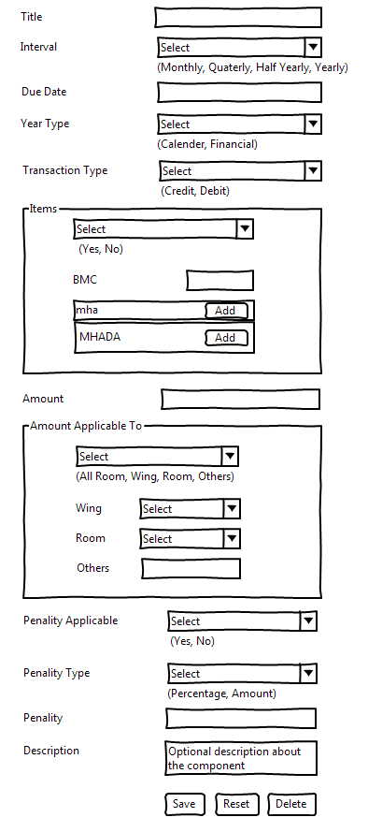
On Success:

Action | Data
Redirect | Component List Page

On Failure:

Action | Data
Show Message | Failed to add component

Services:

Operation | Service Reference Number
Form Submit | SERVICE_0002

